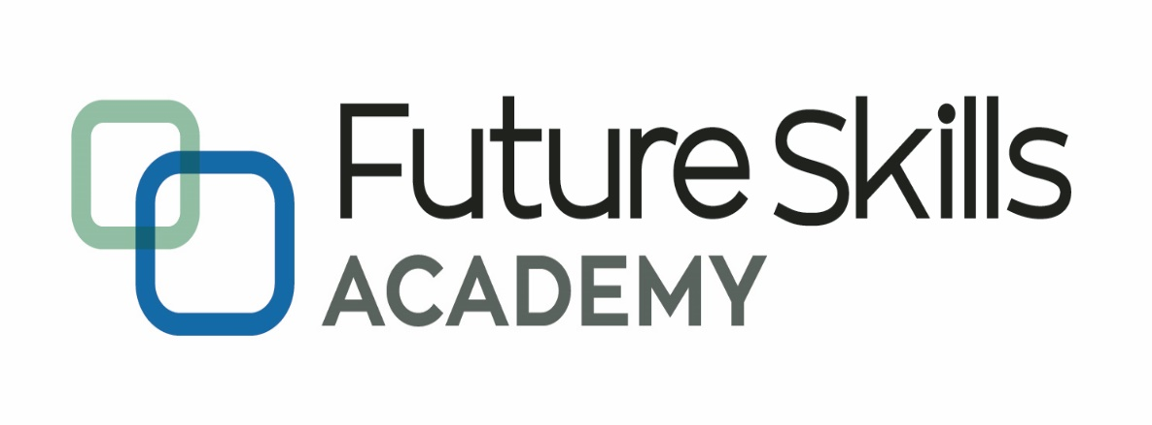

*Capable People, Capable Communities*

**Micro-Credentials in Software Development**

**Certificate in Software Development**

**MCSD51**

**Project Proposal**

**MISUN HWANG**

**August 2022**

Contents

**Introduction** 3

**Scope** 3

**User stories and use cases** 3

**Ethical and cultural impact** 5

**SDLC** 5

**Project timeline** 5

**Diagrams** 6

# Introduction

It is very difficult for people with little work experience trying to write a CV for a new job. But even those who have too much work experience struggle to choose work experience by role to apply for a new job. This is because they have to reselect detailed career for each role they want to apply for, rewrite a CV, and write a new cover letter that fits that role. Occasionally they miss an opportunity because they cannot submit their application right away when they need it. In this project, I propose to build a web application that automatically generates CVs and cover letters based on the role which users are applying for. The system allows users to view job-specific CVs and cover letters and download them as standardized documents. The target users of this system are job seekers with experience in various fields.

# Scope

The ultimate goal of this project is to log in for each person, register their career information, filter career information by role, view CV and Cover Letter on the screen, and download it as a file or send it by email. However, given the short project period of 4 weeks, in this project, I want to implement a system for one user, and will contain only 3 essential functions. These are the adding page of each career information, the view page that shows the CV composed of only those items by filtering the career details according to the role entered, and the page that maps to the existing career details when adding a new role. However, for future functional expansion, designing a database will be considered for multiple users.

# User stories and use cases

**User Stories**

As a job seeker, I need to store my career information whenever I perform tasks as a new role, so that I can manage my work experience systematically.

As a job seeker, I want to view my job experience regarding to a specific role with a standard CV format, so that I can reduce the preparation time for a job and quickly submit my application.

As a job seeker, I want to download my customized CV, so that I can reduce the preparation time for a job and quickly submit my application.

As a job seeker, I want to view my cover letter, which is generated automatically, regarding to a specific role, so that I can reduce the preparation time for a job and quickly submit my application.

As a job seeker, I want to download my customized cover letter, so that I can reduce the preparation time for a job and quickly submit my application.

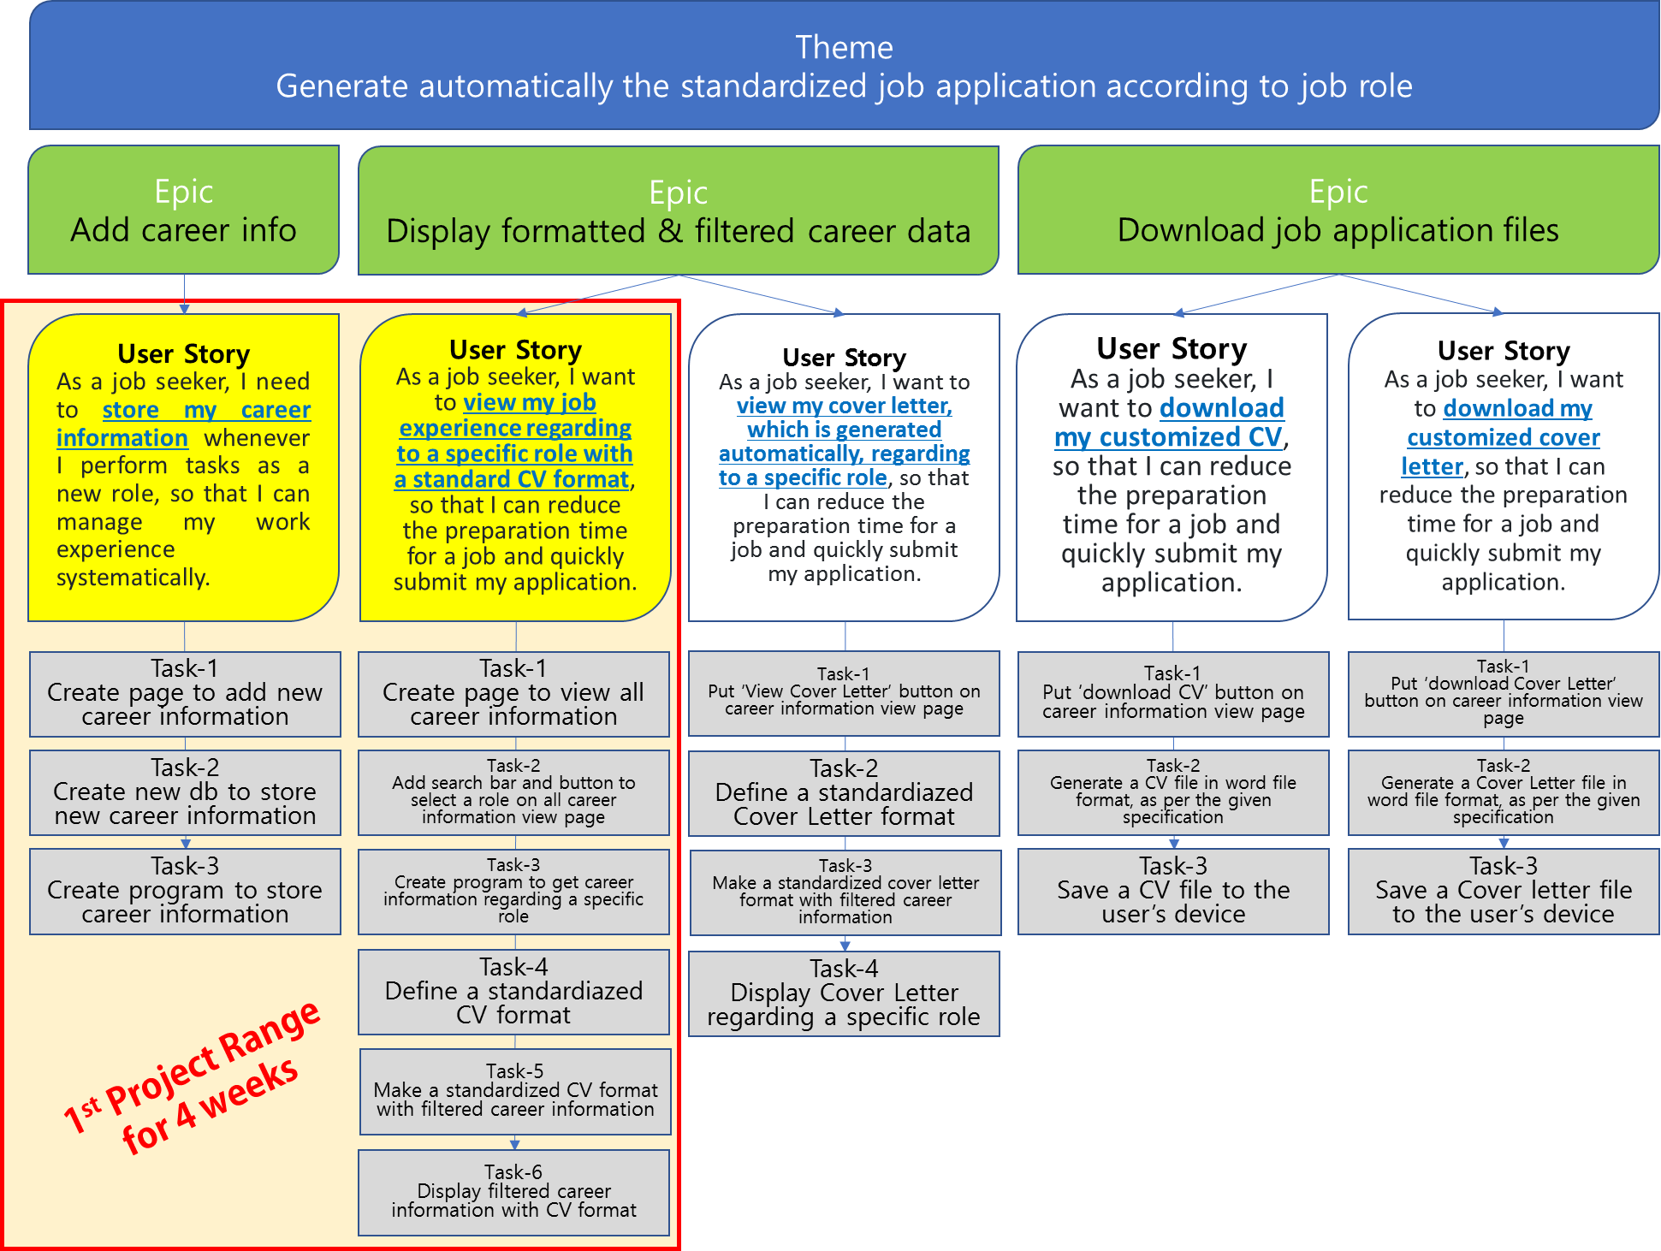

**Use Cases for 1st Project Range**

**Actor**

The system is for job seekers. So, all activity will be operated by them. So ‘a Job Seeker’ is a primary actor for this system. However, this system should have a predefined CV format to generate it when user requests. So ‘System’ becomes a supporting actor.

**Use Case**

|  |  |  |
| --- | --- | --- |
| **Use Case** | **Description** | **Related User Story** |
| Add personal information | A job seeker adds personal information for CV header | As a job seeker, I need to store my career information whenever I perform tasks as a new role, so that I can manage my work experience systematically. |
| Add new career | A job seeker adds a new job experience |
| Add new role | A job seeker adds new role title |
| Assign role to career | A job seeker maps their career to roles |
| View all career history | A job seeker views his/her all job experience | As a job seeker, I want to view my job experience regarding to a specific role with a standard CV format, so that I can reduce the preparation time for a job and quickly submit my application. |
| Search for career regarding filtered role | A job seeker searches limited work history about a specific role |
| Generate and display CV having filtered career | System generates formatted CV data and display it according to the searching event. |
| Print out the screen | A job seeker prints out the search results having formatted career information |
| Define CV format | System stores a display format |

# Ethical and cultural impact

This system is composed of personal career information and it should be secure carefully. So, all input information will be safely stored and managed in a database to prevent unauthorized leakage of the user's information. In addition, it will be designed as a user-based system so that no one other than the user can modify the information.

For avoiding discriminable aspect of society, this system does not ask personal information such as gender, age, religion, ethnicity.

# SDLC

I chose to use the Waterfall software development methodology for 1st Project range. Because the requirements are clearly stated in the beginning. Also, since the project must be completed within a short project period, multiple reviews and iterative development cannot be allowed. Instead, I will include the contents so that all requirements for each development stage can be reflected. Other than that, the waterfall methodology lets me know where my project is and where it should be at any given time thanks to its sequential methodology.

# Project timeline

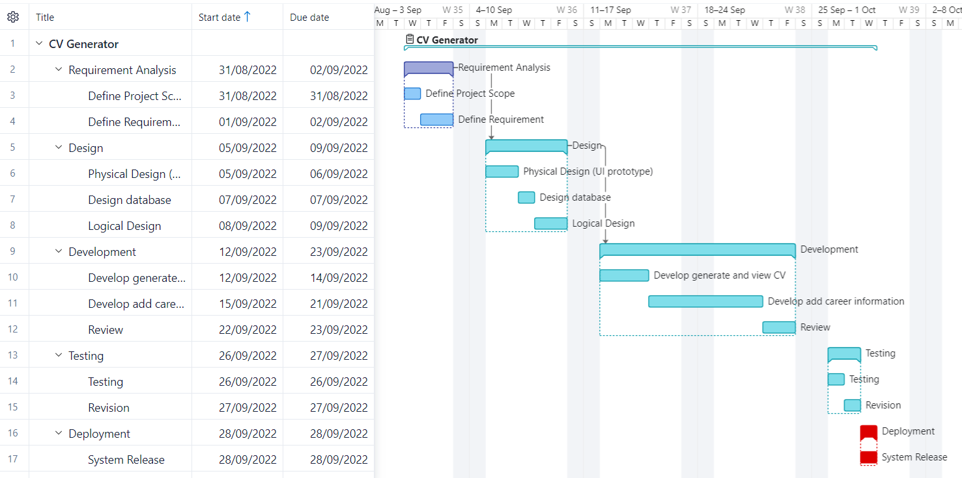

# Diagrams

**Use Case Diagram**

# References

Bobert Half (2021), *6 Basic SDLC Methodologies: Which One is Best?*, https://www.roberthalf.com/blog/salaries-and-skills/6-basic-sdlc-methodologies-which-one-is-best

George Lawton (2020), *5 examples of ethical issues in software development*, https://www.techtarget.com/searchsoftwarequality/tip/5-examples-of-ethical-issues-in-software-development

Lucid Content Team (?), *What the Waterfall Project Management Methodology Can (and Can’t) Do for You*, https://www.lucidchart.com/blog/waterfall-project-management-methodology